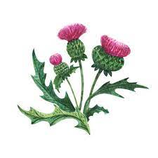
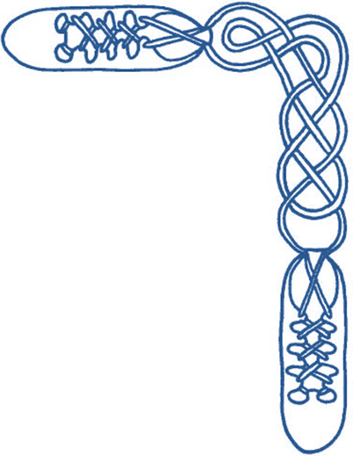
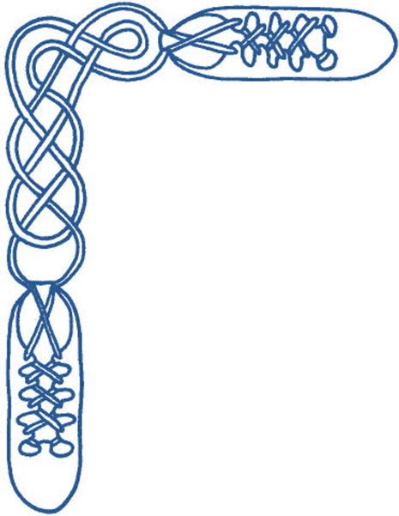

Harrow & District Caledonian Society

Summer Dance

Wednesday 3rd June 2026

from 7:30 until 10:30 pm

St Alban’s Church Hall, Norwood Drive, Harrow, HA2 7PE

dancing to the music of Chris Oxtoby

Admission £12 (£6 for juniors and non-dancers) – please bring a contribution to the refreshment table

JIM'S HABERDASHERY (J8x40) 3C (4C set) www.youtube.com/watch?v=t_vm54-1nrg&t=7 Alan MacPherson Bannockburn 700
1- 8 1s+2s dance Double Fig of 8 (1s crossing down, 2s dancing up)
9-16 1M+2M turn RH & 1L+2L turn LH 1½ times (4 bars),
1s dance out own side, down behind 3s & cross up to 2nd place opposite sides
17-24 1s dance reels of 3 on opposite sides (1s out & up/2s in & down to start), 1s end crossing up to 2nd place own sides
25-32 1s dance reels of 3 on own sides (1s out & up to start), 1s end in centre facing up
33-40 1s dance up to top, cast to 2nd place & 2s+1s+3s turn RH

FALLS OF ROGIE, THE (R8x32) 3C (4C set) www.youtube.com/watch?v=KKjNOhYswr4&t=9 Jean Attwood Alexander Book 1
1- 8 1s cross RH & cast 1 place, 1s cross RH & cast 1 place (Man up Lady down)
9-16 1s dance ½ reels of 3 across (1M with 2s & 1L with 3s), set in lines across & change places RH with opposite person
17-24 2s+1s+3s chase clockwise ½ way,
1s dance in & turn RH to face 1st corner positions as 2s & 3s continue to chase on to places (as bar 16)
25-32 1s dance ½ reel of 4 with 1st corners, passing RSh dance ½ reel with 2nd corners & cross passing RSh to 2nd place own sides

CHASING THE ECLIPSE (S3x32) 3C set www.youtube.com/watch?v=_1scIYYG8wU&t=9s Sandy Gallamore Highland Road Collection
1- 8 1s set, dance down below 3s (2s step up), cast up to 2nd place, pass LSh to face 1st corners
9-16 1s dance RSh reels of 3 on opposite sides, 1s end facing 1st corners
17-24 1s set to 1st corners, dance ¾ round partner by RSh,
1s set to 2nd corners, dance round partner to own side, facing out
25-32 Promenade (Chaperoned) Chain progression:
25-26 2s and 3s ¾ turn partner RH into middle while 1s dance clockwise ¼ round the set picking up 2L/3M...
27-30 who promenade ½ way clockwise while middle people (2M + 3L) turn LH 1½.
31-32 2s and 3s turn partner RH ¾ to own sides while 1s dance clockwise ¼ round to end in 2nd place. 312

SHINKANSEN (The Bullet Train) (R8x32) 3C (4C set) www.youtube.com/watch?v=5NEjBixsT_A Ann Dix Reel Friends 3
1- 8 1s+3s dance Double Fig of 8 round 2s
9-16 1s set, dance down middle NHJ, cast up round 3s into middle and dance up to places (face out)
while 2s stand for 2 bars, set, dance down middle NHJ and cast up round 3s to places (face in)
while 3s stand for 4 bars, set, dance into middle (face down, NHJ briefly) and cast back to places (face out)
17-24 1s+2s+3s dance reels of 3 on sides (1s out and down to start)
25-32 1s+2s dance Poussette. 213

WATERNISH TANGLE, THE (J8x32) 3C (4C set) www.youtube.com/watch?v=Fs22cAbbJNU Andrea Barfoot Skye Coll 2 & RSCDS Book 54
1- 8 1s cross down RH & set (2s step up 1-2): 1s cross down LH & set (3s step up 5-6)
9-16 1s cross RH, change places on sides with 3s LH; 2s+1s cross RH & ¾ turn LH on sides to form line of 4 across
17-24 2s+1s dance the Targe :
`17-18 1st & 2nd Ladies ¾ turn RH while Men dance ¼ way round anticlockwise
`19-20 1st Man with 2nd Lady & 1st Lady with 2nd Man full turn LH
`21-22 1st & 2nd Ladies ¾ turn RH while Men dance ¼ way round anticlockwise
` 23-24 1st Man with 2nd Lady & 1st Lady with 2nd Man turn ¾ LH to end on sides to 2(1)3
25-32 1s cross down below 3s, cast up, dance up between 2s & cast to 2nd place

REMEMBERING ABBOTSFORD (S4x32) Sq set www.youtube.com/watch?v=8rXALDJqKmU Maggie & Duncan Keppie Haliburton Book 2
1- 8 All dance interlocking (circular) reels of 4 (RSh to partner to start)
9-16 1s & 3s set, cross passing opposite dancer by RSh; 1s & 3s chase clockwise back to place (Men with partner on left)
17-24 2s & 4s repeat 9-16
25-32 All turn corner LH 1¼ (Men on outside) & take prom hold;
All promenade clockwise 1 pl with new partner, Retain RH, Ladies pull back RSh & turn under raised arms to face new partner
End: Men in original places with new partner, Ladies having moved 1 place clockwise

DONALD MACNEIL (H8x32) 3C (4C set) [no video] Margaret Henderson
1-8 1s NHJ dance down to 2nd place (2 bars) (2s step up) finishing back to back facing out
Double Triangles with 2s and 3s (6 bars)
9-16 1s dance ½ diagonal reel of 4 with 1st corners, and pass RSh 1s dance ½ diagonal reel of 4 with 2nd corners,
finishing with 1s in the middle taking LH and giving RH to 3rd corners (currently your 1st crnr person)
17-24 Balance in line (2nd corners also set)
1s turn half way while all corners dance on one place clockwise
Balance in line with 1st corner position, 1L with 2L, 1M with 3M (again all set)
1s turn ¾ into 2nd place while corners dance on one place clockwise.
25-32 All circle 6H round & back

AVIATOR, THE (J8x32) 3C (4C set) www.youtube.com/watch?v=hM51UnMI09M&t=14s Carola Fischer RSCDS Book 52
1- 8 1s lead down, on bar 4 1M crosses partner in front & 1L followed by 1M cast up behind 4M & 3M & across
into 2nd place facing 3L (2s step up 3-4)
9-16 1s (1L leading) dance ½ alternating tandem reel with 1st corners;
1M continues reel with corners passing 3L LSh while 1L+3M turn LH to face 2L
17-24 1s (1M leading) dance ½ alternating tandem reel with 2nd corners;
1L continues reel with corners passing 2L LSh while 1M+3L turn LH.
1s end in 2nd place opp sides, 1L facing out
25-32 1s dance up, round 2s by RSh (1L behind 2M, 1M in front 2L) & 1M followed by 1L cast 1 place, across set
to end in 2nd place own side (6 bars). All 3 couples set

- I N T E R V A L -
with bring and share refreshments

RUTLAND REEL, THE (R8x40) 3C (4C set) www.youtube.com/watch?v=ljiqhX21y30&t=11s Robert Senior RSCDS Book 48
1- 8 1s set & cast 1 place, 1s cross below 3s & cast up to 2nd place opposite sides
9-16 1s+2s dance Ladies Chain & end 1s facing down.
17-24 1s dance reel of 3 on sides giving (RSh to 3s) & 1s+3s ½ turn RH. 2 3 (1)
25-32 1s+3s dance Mens Chain & end 1L end facing out with partner ready to follow her
33-40 1L casts up & crosses to own side while 1M crosses & casts up to end 2nd place own sides, 1s+3s circle left

CHEQUERED COURT, THE (J8x32) 3C (4C set) www.youtube.com/watch?v=FqOEZsW4MP8 Duncan Brown RSCDS Book 42
1- 8 1s cross RH, cast 1 place, 1s dance ½ Figs of 8 (Man round 2s & Lady round 3s) & end facing 1st corners
9-16 1s dance Pass+Turn with 1st corners & 1s twirl round in centre to face 4th corners,
1s dance Pass+Turn with 4th corners & twirl round to face own sides
17-24 1s dance 6 bars of Double Triangles & end with 1L between 2s facing 2L & 1M between 3s facing 3M
25-32 1s dance reel of 3 across giving RSh to 4th corners & 1s cross RH to own sides

WATER OF LEITH, THE (S4x32) 4C set www.youtube.com/watch?v=iDpctXSObCo&t=8s John Wilkinson Edinburgh 90th Anniv
1- 8 1s+3s set. 1L dances down, casts up round 2M into middle facing down as 1M dances across, casts round 2L into middle facing up while 3s dance same round 4s. 1s+3s change places RH with partner into line of 4 in middle (M face down, L face up)
9-16 1s+3s dance reel of 4 in middle
17-20 1s+2s also 3s+4s dance RH across
21-24 1M followed by 1L casts round 2L to 2nd place own sides as 3M followed by 3L casts round 4L to 4th place (2s+4s step up 23-24)
25-32 1s+4s (middle couples) dance Espagnole:
25-26 1s+4s cross (Ladies lead across RH passing between Men) with Ladies changing places RH
27-28 1s+4s cross back (Men lead across RH between Ladies) with Men changing places RH
29-32 4s turn RH as 1s turn LH

TORRIDON LASSIES (J8x40) 3C (4C set) www.youtube.com/watch?v=f9q5cT8u0BM&t=14 John Brenchley Kangaroo Paw
1- 8 1s cross & cast 1 place, 1s dance LH across (1L with 2s, 1M with 3s) & end facing 4th corner
9-16 1s set to corners then to partner & end facing 1st corners, turn corners RH & pass partner LSh to face 2nd corners
17-24 1s dance ½ diagonal reel of 4 with 2nd corners & pass LSh to face 3rd corners,
1s set to corners then to partner & end facing 4th corners
25-32 1s turn 4th corner (pstn) RH & pass partner LSh to face 1st corners,
1s dance ½ diag reel of 4 with 1st corners & finish RSh to RSh (1M facing up, 1L facing down)
33-40 1s dance RSh round 2nd corners & ½ Fig of 8 (1L up, 1M down) while 2s+3s set & cross RH,
set (facing up/down) & change pl RH on sides. 2 1 3

ORCHARDS OF CO. ARMAGH, THE (S3x32) 3C set www.youtube.com/watch?v=oam1r7yjMuA&t=16s Jinty Anderson Belfast Plat Anniv & RSCDS Bk 53
1- 8 1M leading 2M+3M also 3L leading 2L+1L chase clockwise ½ round to opposite sides (4 bars).
All set, 1s+3s turn partners ¾ RH into line up/down (Men facing down)
9-16 3s+1s dance ½ reel of 4. Bar 12: 1M+3L pass LSh to face 2s (1M+2M and 3L+2L facing), 1L+3M remain in centre at top/bottom
1M+3L+2s dance ½ reel of 4 across. Bar 16: 1M and 3L pass LSh to face partners up/down set
17-24 1s+3s dance ½ reel of 4, 1M+3L pass LSh to face own partners.
3s+1s set, Petronella turn to own sides. 321
25-32 2s followed by 1s dance up to top, cast, 2s to 3rd place, 1s to 2nd place (4 bars). 3s+1s+2s turn partners 2H

SCOTT MEIKLE (R4x32) 4C set www.youtube.com/watch?v=DhE0LHERekE&t=7s Alice McLean Laurieston Collection vol 1
1- 8 1s cross RH & cast to 2nd place, 1s dance ½ Fig of 8 round 2s
9-16 1s+3s dance RH across, LH back
17-24 1L followed by 3L dance Tandem reel of 3 across with 2s (1L ends 3rd pl)
while 3M followed by 1M reel of 3 with 4s (3M to 2nd pl)
25-32 1s+4s dance ½ R&L, turn partners RH 1½ times

TRIP TO TIMBER RIDGE (R8x32) 3C (4C set) www.youtube.com/watch?v=B6h9iyUHlP8 Linda Henderson Heart of SF & RSCDS Book 52
1- 8 1s turn RH, cast (2s step up) then 1L+2s & 1M+3s dance RH across. 1s end facing 1st corners
9-16 1s dance Corner Pass+Turn with 1st corners, pass RSh & repeat with 2nd corners. 1s pull back RSh
to end BtoB in centre facing opp sides
17-24 2s+1s+3s dance Double Triangles. Bars 23-24 1s petronella turn to 2nd place own sides
25-32 2s+1s+3s circle 6H round and back
Classes continue 17th June to 16th July (AGM so no class 10th June)

Summer activities include Lunch, Picnic, Bowls and weekend away

Classes resume after summer break in early September

– All welcome –



