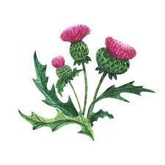
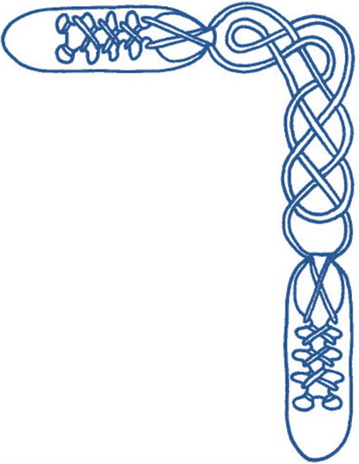
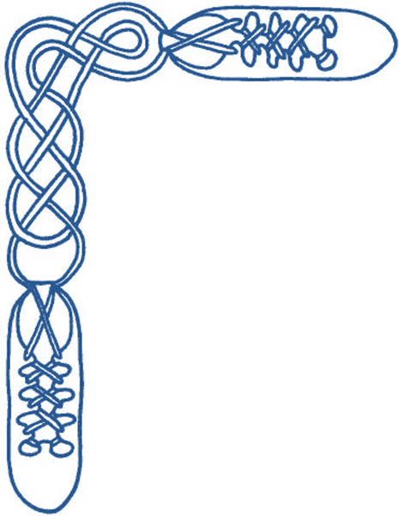

Harrow & District Caledonian Society

Summer Dance

Wednesday 31st May 2023

from 7:45 until 10:30 pm

St Alban’s Church Hall, Norwood Drive, Harrow, HA2 7PE

dancing to the music of Adam Brady

Admission £10 (£5 for juniors and non-dancers) – please bring a contribution to the refreshment table

AULD GREY CAT, THE (Boyd) (R8x32) 3C (4C set) www.youtube.com/watch?v=aLkt8S6dKV8 Iain Boyd Let's All Dance
1-8 1s cross RH & cast 1 place (2s step up), 1s cross LH & cast up to original places (2s step down)
9-16 1s dance reflection reels of 3 on sides (in & down to start)
17-24 1s lead down the middle & back to place
25-32 1s+2s dance Allemande

MISS ELEANOR (S3x32) 3C set www.youtube.com/watch?v=AiXD4Mhkwg4&t=20 Ann Dix RSCDS Book 49
1- 8 Mirror reels of 3 on sides (1s start by going in and down)
9-16 1s set and cast off, turn RH to face out and cast to their right, ready for
17-24 3 couple Bourrel
' 1M+3L also 2M+1L set advancing diag and ¾ turn 2H to line up/down middle & twirl to face own partners
while 3M and 2L chase anticlockwise to face partner
All set to partner and turn 2H to own sides 3 1 2
25-32 Circle 6 hands round and back

GATES OF INDIA (J4x32) 4C set Jean Attwood Alexander Dances Book 8
The Gates of India are a triple arch, a replica of the gates of Negapatum, on top of Knock Fyrish near Alness on the Cromarty Firth built in the late C18th to relieve local unemployment (instigated by Genl Sir Hector Munro)
1- 8 1s with 2s and 3s with 4s dance ½ R&L
All cross RH, end couples (2s + 3s) set while 1L+4L and 1M+4M turn LH ¾ on the sides
into line of 4 across the set, 1M + 4L joining RH
9-16 1s + 4s set in line, ½ turn adjacent person LH,
1s + 4s set in line, ¾ turn adjacent person LH, ending 2,1,4,3, facing up and down ready for
17-24 ½ reel of 4 on sides; ending 3 4 1 2 as if continuing the reel, ready for RH turn at ends
All turn RH once round, releasing hands on bar 23 so that 4s pass 1s (in centre) RSh [as in Macleod’s Fancy] to end 3,1,4,2.
25-32 All set (taking hands on sides), Men make an arch and all cross RSh to opposite side
All chase clockwise half way to finish on own sides 2,4,1,3

GLASTONBURY TOR (R8x32) 3C (4C set) www.youtube.com/watch?v=N4dtvlD7h08 Duncan Brown RSCDS Book 47
1- 8 1s+2s set & dance RH across ½ way, 1s+3s set & dance LH across ½ way
9-16 1s set & cross RH, 1s cast up 1 place & turn LH turn to face 1st corners
17-24 1s dance ½ reel of 4 with 1st corners & pass left to face 2nd crnrs, 1s dance ½ reel of 4 with 2nd corners & curve right
to end 1M between 3s & 1L between 2s
25-32 1M+3s also 1L +2s Set+Link for 3 once, 1s turn RH 1½ times to 2nd place as 2s & 3s dance clockwise ½ way to places 2 1 3

CITY OF BELFAST (S3x32) 3C set www.youtube.com/watch?v=dfpPDV8WhRA&t=13 L Mullholland Belfast Diamond Jubilee Book
1- 8 1s dance ½ Fig of 8 round 2s, 1L+2M turn RH 1¼ times while 1M+2L turn LH 1¼ times & 1s end BtoB facing opp sides
9-16 1s+2s dance reel of 4 across & 2s end in 1st places while 1s pass LSh to face 1st corners
17-24 1s set to 1st corner & 2nd corner ending (turning to right) between corners, all set & 1s cross RH
25-32 1s+3s dance Espagnole:
`25-26 1s+3s cross (Ladies lead across RH passing between Men) with Ladies changing places RH
`27-28 1s+3s cross back (Men lead across RH between Ladies) with Men changing places RH
`29-32 3s turn RH as 1s turn LH to end 2 3 1

SPIFFIN' (J5x32) 5C Sq.Set (5s facing 1s) www.youtube.com/watch?v=W6LNwJxiYxM&t=5 David & Avril Quarrie+Friends
1- 8 5s dance reels of 3 with 1s+3s (5s start by passing opposite dancer by LSh)
9-16 5L dances RH across with 2s while 5M dances LH across with 4s, 5s dance NHJ up thru 1s & cast back to centre
17-24 5L dances LH across with 2s while 5M dances RH across with 4s, 5s dance NHJ down thru 3s & cast back to centre
25-32 5s turn (Kilt Grip) twice, 5s+1s set & dance part LH across (5s dance ½ way while 1s dance ¼ way & into centre to face 2s)

IRISH ROVER, THE (R8x32) 3C (4C set) www.youtube.com/watch?v=RSyUYGjcWWk www.youtube.com/watch?v=GQC8WQawW_g&t=5 James Cosh 22 SCDs
1- 8 1s dance down below 3s & cast up to 2nd place own sides
1L dances RH across with 2s while 1M dances RH across with 3s
9-16 1s dance ½ diagonal reel of 4 with 1st corners, ½ diagonal reel of 4 with 2nd corners
& quick ½ turn LH in centre to face 1st corners
17-24 1s dance reels of 3 across giving LSh to 1st corners ending in 2nd place own sides
25-32 1s dance Diagonal R&L (1M crossing down & 1L crossing up to start)

I N T E R V A L

ECCLEFECHAN FELINE (J8x32) https://youtu.be/oMeTBkZL2Hw Bob McMurtry Le Petit Chat Celtique
1- 8 1s dance mirror Fig. of 8 on own sides, taking hands, in & down to start
9-16 1s+2s+3s dance mirror reels of 3, 1s in & down to start
17-24 1s dance down middle (3 bars) & up (3 bars), cast to 2nd place (2 bars)
25-32 2s+1L, 1M+3s dance RH across, 2s+1M, 1L+3s dance LH across

SWAN AND THE TAY, THE (S3x32) 3C set www.youtube.com/watch?v=NlDP6Lt2rNE&t=2s Audrey Saunders Perth 800
1 -8 1s dance Figs 8 own sides dancing in & down to start (giving hands where possible)
9-16 1s cross down to dance reels of 3 on opp sides (joining hands where possible)
& 1s end facing 1st corners, 2s end in 1st place
17-24 1s dance Corners Pass+Turn with 1st corners, pass RSh on bar 20 to face 2nd corners
1s dance Corners Pass+Turn with 2nd corners, pass RSh on bar 24 to end 2nd place own sides
25-32 All set, all cross RH, all chase clockwise ½ way round to own sides 3 1 2

RUTLAND REEL, THE (R8x40) 3C (4C set) www.youtube.com/watch?v=ljiqhX21y30&t=11 Robert Senior RSCDS Book 48
1- 8 1s set & cast 1 place, 1s cross below 3s & cast up to 2nd place opposite sides
9-16 1s+2s dance Ladies Chain & end 1s facing down
17-24 1s dance reel of 3 on sides giving (RSh to 3s) & 1s+3s ½ turn RH. 2 3(1)
25-32 1s+3s dance Mens Chain & end 1L end facing out with partner ready to follow her
33-40 1L casts up & crosses to own side while 1M crosses & casts up to end 2nd place own sides, 1s+3s circle left once round

DREAM CATCHER, THE (S96) Sq.Set www.youtube.com/watch?v=WWW1YaHN8BQ&t=3m21s Eileen Orr RSCDS Book 45
1- 8 All circle 8H round & back
9-16 1s+3s dance the Swirl: -
turn partner RH into Allemande hold & dance LSh round other couple ½ way,
dance LH across ¾ way & swirl to face side couples (BtoB with ptnr & Lady facing Man)
17-24 All dance reels of 4 across
25-32 All set & dancing couples dance out between side couples, cross & cast to change places RH with partner back into places
33-40 All set & advance with partners, retire diagonally with corners & set
41-48 1L+4M dance R&L with 3L+2M (on diagonal)
49-56 1M+2L dance R&L with 3M+4L (other diagonal)
57-64 All set with corners, Adv+Ret with partners & set
65-88 2s & 4s repeat bars 9-32
89-96 All circle 8H round & back

MAIRI'S WEDDING (R8x40) 3C (4C set) www.youtube.com/watch?v=l6O_8Xf2G8c James Cosh 22 SCDs
1- 8 1s turn RH & cast to 2nd place, 1s turn LH to face 1st corners
9-16 1s dance ½ diagonal reel of 4 with 1st corners, 1s dance ½ diagonal reel with 2nd corners
17-24 1s dance ½ diagonal reel with 3rd corner (pstns), ½ diagonal reel with 4th corner (pstns)
25-32 1s dance reel of 3 across (Lady with 2s, Man with 3s - LSh to 1st corner)
33-40 2s+1s+3s circle 6H round & back

PLANTATION REEL, THE (R5x32) 5C set www.youtube.com/watch?v=EH3sUzfmO9M Tony Moretti Pinewoods Collection 2
1- 8 1s & 3s cross RH & cast down 1 place,
lead down between the couple below & cast back to 2nd/4th place (opposite sides)
9-16 2s+1s & 4s+3s dance ½ R&L,
& Petronella turn 2 places anticlockwise round square (end in same places as at bar 8)
17-24 All dance RH across (1M with 2s, 1L+3M with 4s, 3L with 5s) & 1s & 3s change places with partners
to dance LH across
25-32 1s & 3s cross RH cast down 1 place & all turn RH
Classes continue 14th June to 12th July (AGM so no class 7th June)

Classes resume after summer break in early September

– All welcome –

